CONTRACT DOCUMENTS AND SPECIFICATIONS FOR THE PUTNAM COUNTY LAND REUTILIZATION CORPORATION
Demolition of 10487 SR 15,151 North Dr, 968 N. Defiance St, Ottawa OH, & 141 S. Main St, Glandorf OH 45848

* Photos are provided at the end.

Prepared for:
Putnam County Land Reutilization Corporation
245 E. Main St, Suite 101
Ottawa, OH 45875

Prepared by:
Maumee Valley Planning Organization
1300 E Second Street, Suite 200
Defiance, OH 43512
419-784-3882

SECTION 1: DEMOLITION PLAN & SCOPE OF WORK

1.1 Introduction

Maumee Valley Planning Organization (MVPO) has been tasked by the Putnam County Land Reutilization Corporation (PCLRC) to develop a demolition plan for 10487 SR 15, 141 S. Main St, 151 North Dr, 968 N. Defiance St, Ottawa, OH 45875. This demolition is being funded by an Ohio Department of Development Site Revitalization grant.

1.2 Bid Opening & Award Date

Bids will be received at the next Putnam County Land Reutilization Corporation meeting which is located in the Putnam County Commissioners Office at 245 E. Main St, Suite 101, Ottawa OH 45875 until 10:45 a.m. (local time), on TUESDAY, MAY 13TH, 2025, at which time and place bids will be opened publicly and read aloud. Bids received after 10:45 a.m. will be returned unopened.

The anticipated award and contract execution date is contingent upon receiving an executed Grant Agreement from the State. An email message will be sent to all contractors submitting on this project alerting them of the tentative awardee no later than MAY 20TH, 2025.

1.3 Work Dates

Contractor must notify Maumee Valley Planning Organization (MVPO) and adjacent neighbors of the date and time of demolition at least 48 hours prior to commencing work. Contractor cannot begin work until a Notice to Proceed has been issued. Work must be completed by October 30th, 2025. Change orders are required for any changes in scope to original bid. Contact MVPO with questions or changes.

1.4 Pre-planning and Notifications

The selected Contractor will be responsible for appropriate permits from the village, county, and other agencies, as required. Permits include, but are not limited to demolition, well sealing, and septic pumping. The demolition Contractor will be notified when asbestos-containing materials are abated prior to demolition. A copy of the asbestos abatement and inspection report will be provided to the demolition Contractor prior to demolition of the buildings.

The demolition/abatement Contractor shall submit a Notification for Demolition and Renovation form to Ohio EPA, Division of Air Pollution Control at least 10 working days prior to demolition start date. This Notification must be turned in to MVPO. Please note that the Notification fee will be the responsibility of the contractor.

1.5 Disconnection of Utilities

The Demolition Contractor shall coordinate with FCLRC/the Village of Ottawa to schedule utility disconnects for water, sanitary sewer, and natural gas (if present). The utility lines will be capped at the main line to ensure there is no loss of utilities to surrounding properties.

1.6 Identification of items to be salvaged

No items will need to be salvaged.

1.7 Scope of Work for Demolition of building(s)

Demolition will be performed by an Ohio-registered demolition Contractor. Demolition will proceed as follows:
- Demolition will proceed by use of excavators equipped with concrete breakers, grapples, and other modern hydraulic demolition tools and attachments.
- General building/structure demolition will not interfere or encroach upon surrounding pedestrian and vehicular traffic during normal activities
- The Contractor shall provide fence around the project area and will work within the confines of that fencing, whenever possible.

Note that due to the location of the building, the Contractor must ensure that streets and adjacent buildings/properties are not negatively impacted by the demolition process. Upon completion of demolition all demolition debris will be handled as construction demolition debris by the demolition Contractor and properly recycled, when possible.

10487 SR 15, Ottawa OH 45875
- Building and patio are to be demolished
- There is a well that will need to be kept; there is a septic tank that will not be kept
- Unsure if there is a cistern
- Site finish will be stone
141 S. Main St, Glandorf OH 45848
- White barn shop is only structure to be demolished, there is a long open shed and 3 temporary metal buildings on the property that will stay
- Other cleanup includes the concrete floor of the barn shop
- Site finish will be stone
151 North Dr, Ottawa OH 45875
- Single family home is the only structure on the property and will be demolished
- The site finish will be grass
- Other cleanup includes a sidewalk that leads up to the house
- Unsure whether there is a basement or not
968 N. Defiance St, Ottawa OH 45875
- A house and shed are on the property and need to both be demolished
- There is no other cleanup needed on the property
- The site finish will be grass

1.8 Proper removal and off-site disposal of debris & Asbestos
The Contractor shall follow guidance provided in OAC 3745-400 for disposal and beneficial use of construction and demolition debris. Erie Environmental will be performing the Asbestos Abatement prior to contractor performing demolition.

1.9 Site completion

Following demolition, excavations, holes, or depressions will be backfilled and graded with clean fill dirt at a 95% compaction rate. The site should then be finished with a thin layer of topsoil and finished off with planted grass seed.

1.10 Additional Detailed Technical Specifications
- Permits: At the Contractor’s expense, all required permits, including, but not limited to demolition, well sealing and septic pumping and all appropriate permits from the Land Bank, county, and other agencies, as required should be obtained by the contractor and sent to MVPO.
- Utilities: Contractors are responsible for ensuring utilities are shut off at each project location and ensure there is no loss of utilities to surrounding properties. Notify the Ohio Utility Protection Service in a timely manner and properly bulkhead sewer connection if applicable. Contractor shall be responsible for contacting utility services.
- Asbestos: Asbestos inspection will be completed by J&K Environmental Services, Inc. and, if needed, asbestos abatement will be contracted separately. If applicable, asbestos abatement must be completed prior to demolition beginning.
- 10-day EPA Notice: The demolition Contractor shall submit a Notification for Demolition and Renovation form to Ohio EPA, Division of Air Pollution Control at least 10 working days prior to the demolition start date. The Notification must be turned into the Land Bank. Please note that the Notification fee will be the responsibility of the Contractor. The 10-day EPA notice is required to receive a Notice to Proceed from the Land Bank.
- Pre-Demolition Site Visit: Contractor must coordinate with Land Bank (MVPO) and property owner to conduct a pre-demolition site visit at the site of the demolition. This is required prior to issuing a Notice to Proceed.
- Notice to Proceed: Contractor may NOT begin work until a Notice to Proceed has been executed.
- Land Bank and Owner Notice: Contractor must notify the Land Bank and owner at least 48 hours prior to commencing the demolition. Contractor must also provide a timeline of work and their expected dates on site.
- Paperwork and Required Documentation: Contractor must be pre-qualified with MVPO prior to quoting projects. Copies of Contractor’s and Subcontractor’s Workers Compensation, General Liability Insurance and W-9 must be provided by Contractor prior to signing contract. Contractor is responsible for providing MVPO updated copies when documents have expired or otherwise changed.
- General: Except as otherwise stated, the Contractor shall provide and pay for all materials, labor, tools, equipment, water, light, heat, power, transportation, superintendence, temporary construction of every nature, charges, levies, fees, or other expenses incurred and all other services and facilities of every nature whatsoever necessary for their performance of the Contract within the specified time.
- Expectations and Unique Site Conditions: The Contractor is expected to provide all necessary labor and materials to complete the scope of work. Contractor is expected to notify MVPO/Land Bank of any unique site conditions that require immediate discussion.
- Removal of Debris & Structures: Contractor will demolish and haul away the building(s) to a legally pre-approved site; The Contractor shall follow guidance provided in Ohio Administrative Code (OAC) 3745-400 for disposal and beneficial use of construction and demolition debris. Contractor must provide Land Fill receipts.
- Land Fill Receipts: The Contractor shall provide MVPO with verified original receipts from an approved land fill or dump site. Receipts must be received prior to submission of an invoice, as an additional condition of payment for work performed, as evidence that all waste material from the job site contracted herein was disposed of in a proper manner. Receipts shall contain the job address, location of the land fill or dump site, cubic yardage dumped, and must also bear the signature of the Contractor’s driver. If such land fill receipts are not provided, Land Bank shall withhold payment until received and approved thereof. Contractors may not dump at unauthorized locations such as privately owned land.
- Paperwork and Required Documentation: Other required documentation to be submitted includes the 10-day EPA Notice, land fill receipts, photos, permits, and invoices. In addition, the Land Bank reserves the right to request additional documents related to the project that are not listed here.
- Photographs during demolition must be submitted prior to issue of payment or submission of an invoice. Photographs, from all angles, required include:
  - Before, during and after photos
  - A photo of the site without the structure BEFORE final site finish and AFTER final site finish
  - If there is a basement, a photo of the clean basement hole
  - A photo of the clean fill dirt used to fill basement/other holes
  - Contractor must also demonstrate proof of removal/abandonment of a well/septic or cistern.
  - Failure to turn in the above items will impact Contractor pay.
- Basements: Contractor shall demolish and haul away any and all required basement walls, and basement columns to a legally pre-approved site; and further break and remove the basement floor leaving a clean hole, unless otherwise directed by the Land Bank. Photos from all angles of the clean basement hole must be provided to the Land Bank/MVPO OR Contractor may request a “clean hole inspection” in lieu of submitting photos.
- Septic System: If a septic system is in place and is to be abandoned, abandonment must be performed by a properly credentialed individual in conformance with the requirements of the County’s Health Department. Contractor is to pay all fees associated with the abandonment and provide documentation that the system has been satisfactorily abandoned prior to final payment being issued to the contractor.
- Well: If a well is present and is to be abandoned, the abandonment must be in conformance with the requirements of the County’s Health Department. Contractor is responsible to remove and properly dispose of any well equipment located inside or immediately adjacent to the home and provide documentation that the system has been satisfactorily abandoned prior to final payment being issued to the contractor.
- Other Cleanup/Demolition: Contractor is responsible to remove and properly dispose of all brush and debris to allow for fill and finish. Contractor shall remove existing pavement in driveway area, service walks and patios within property lines.
- Trees: All vegetation and trees shall be removed.
- Public sidewalks must remain intact and undamaged. If an existing sidewalk and/or street is damaged during demolition, the contractor shall repair/replace at his expense and in a manner satisfactory to the Land Bank.
- Asphalt, Concrete and Stone: Remove existing asphalt, concrete & stone in building and lot area including approach and service walks within the subject property lines.
- Site Finish & Fill Dirt: The finished site should be level and free of construction debris, brush, and trash in all areas where demolition is performed. Excavation, holes, or depressions will be backfilled and graded with suitable granular or cohesive soils that are clean and free of all organic and inorganic material and contaminants. Following demolition, excavations, holes, or depressions will be backfilled and graded with earthen soil.
- Guarantee: Contractor agrees to supply all labor, equipment, and material to complete the Scope of Work. All labor and material is guaranteed for a period of three (3) years.
- Prevailing Wage: Where the cost of the project exceeds $75,000, provisions of Ohio Revised Code (ORC) Sections 4115.03 to 4115.16, inclusive, as applicable, with respect to the payment of all mechanics and laborers employed in construction work apply.
- Safety: Contractor shall provide protection, warning signs, barricades, fall protection and take all necessary precautions to protect workers and bystanders. Contractors shall also eliminate unnecessary hazards before leaving the jobsite at the end of the day. Hazards such as missing sidewalks and debris must be barricaded with yellow caution tape. In addition, contractors shall reinstall fall protection and safety precautions at the end of each workday if removed during that day.
- Inconvenience to neighbors: The contractor shall attempt to minimize noise, dust, and inconvenience to neighbors. The Contractor will provide labor and use hoses to prevent the discharge of visible emissions to the outside air throughout demolition.
- Change orders: Change orders are approved on a case-by-case basis. Change orders are not approved for work that is included in the original specifications. Do not complete work that requires a change in the scope of work prior to receiving an approved change order. Otherwise, you may not receive payment for that additional work.
- Additional Specifications: Contractor shall comply with any and all specifications and standards in any bid package or as otherwise attached hereto on any Exhibit.

PLEASE SEE EXHIBITS B & C AS PART OF THE CONTRACT DOCUMENTS/SECTION 4 FOR THE FULL LIST OF SPECIFICATIONS/EXPECTATIONS

1.11 Site Photos
10487 SR 15

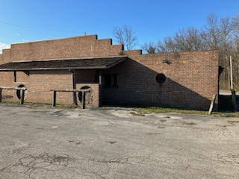

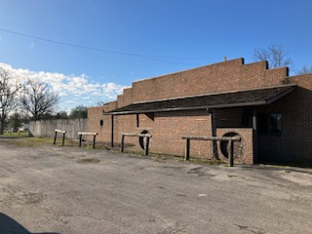

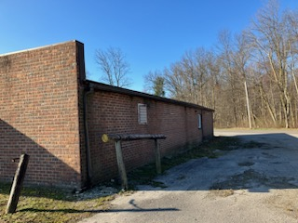

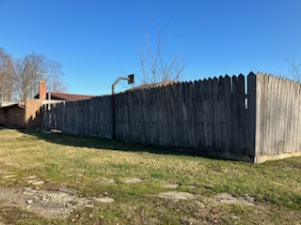

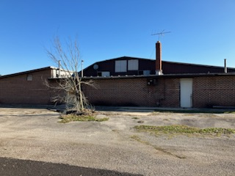

151 North Dr
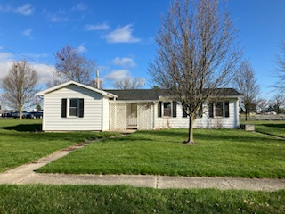

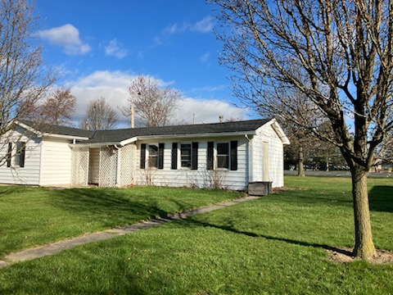

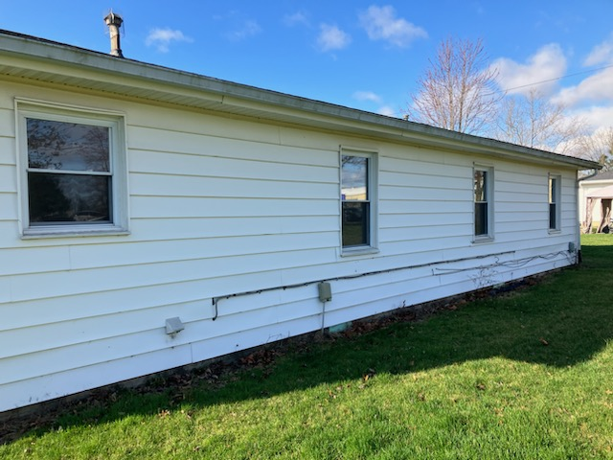

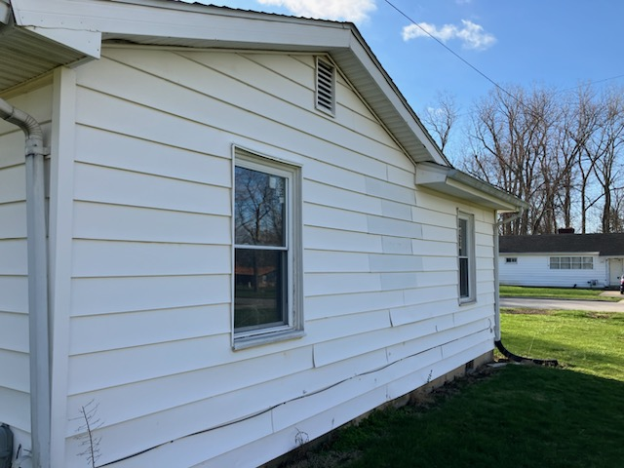

968 N. Defiance St.
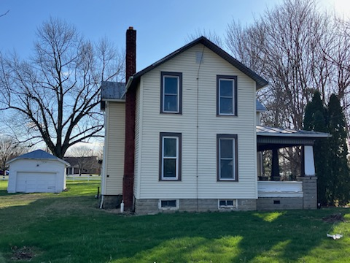

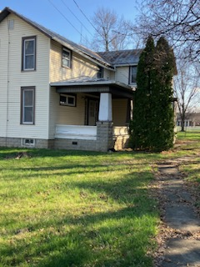
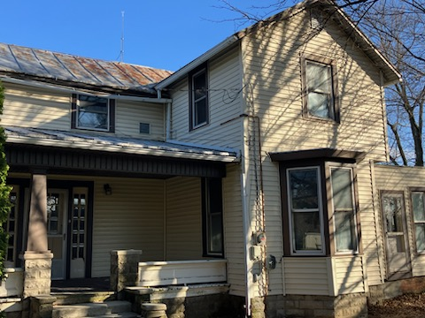

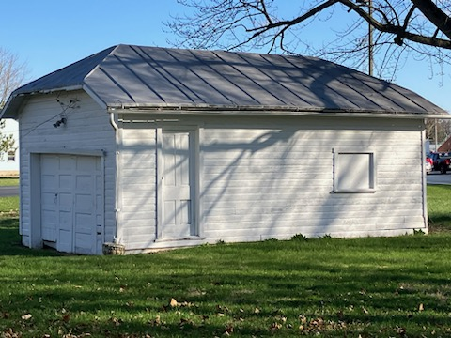

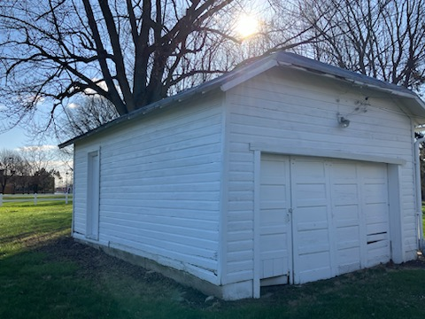

141 S. Main St Glandorf, OH
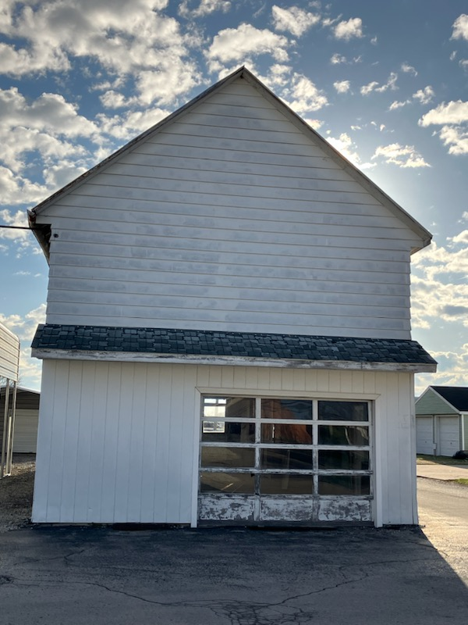

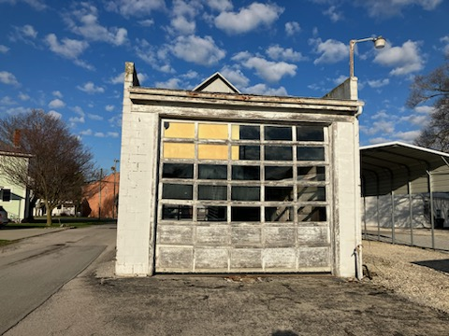

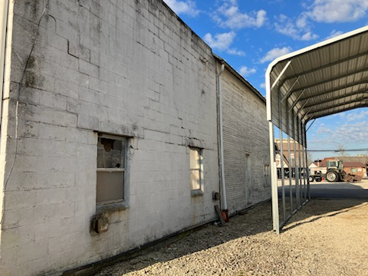

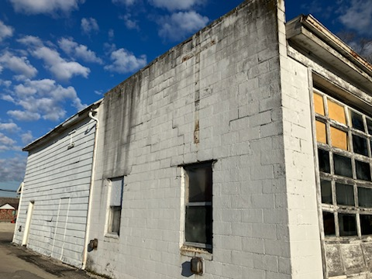

SECTION 2: ADVERTISEMENT TO BIDDERS & BIDDING INSTRUCTIONS

ADVERTISEMENT TO BIDDERS

The Putnam County Land Reutilization Corporation invites bidders to submit sealed bids for the demolition of the following properties:
- 10487 SR 15, Ottawa OH 45875
- 151 North Dr, Ottawa OH 45875
- 958 N. Defiance St, Ottawa OH 45875
- 141 S. Main St, Glandorf OH 45848

Bids will be received at the next Putnam County Land Reutilization Corporation meeting which is located in the Putnam County Commissioners Office at 245 E. Main St, Suite 101, Ottawa, OH 45875 until 10:45 a.m. (local time), on Tuesday, May 13th, 2025, at which time and place bids will be opened publicly and read aloud. Bids received after 10:45 a.m. will be returned unopened.

The contract documents may be obtained in the following ways:
- Online at https://www.mvpo.org/bids;
- Via email, per request to Abby White at demo@mvpo.org; OR
- In-person at the Maumee Valley Planning Organization’s (MVPO) Office Monday – Friday, 8:00 am – 4:30 pm, at 1300 East Second Street, Suite 200, Defiance, OH 43512.

Bids must be submitted to the Putnam County Commissioners Office or to MVPO by the bid opening date and time. Bids must be received in a sealed envelope titled “Putnam County Landbank – [Property Address]” and accompanied with a Bid Guaranty Bond in the amount of 10% of the Bid amount, subject to conditions provided in the Instructions to Bidders. The Bid Guaranty Bond shall be issued by a Surety Company or Corporation licensed in the State of Ohio to provide said surety.

The Putnam County Land Reutilization Corporation reserves the right to reject every bid and to waive informalities, irregularities, and errors in the bidding to the extent permitted by law. The County reserves the right to purchase material from the most economical source. Location of material and job site, as well as any other pertinent factors, will be taken into consideration. No bidder may withdraw their bid within 60 days after the actual date of the opening of the bids.

END OF ADVERTISEMENT TO BIDDERS

Please post ad on April 29th or before

2.1 Pre-Bid Site Walkthrough

An optional walkthrough of 10487 SR 15 will be scheduled for at least one week before the bid opening date. Please fill out the plan holders list to be notified when this walkthrough is scheduled. A PCLRC or MVPO representative must escort potential contractors at all time on the premises. This will be the only opportunity Contractors will have on the property.

2.2 Bid Submittal Deadline & Opening

All bids are due to the Putnam County Commissioner’s office (245 E. Main St, Suite 101, Ottawa, OH 45875) no later than 8:00 am on Tuesday, May 13th, 2025 at which time & place Bids will be read aloud. To ensure bid eligibility, please seal your proposal in an envelope. To submit your bid:
- You may drop your sealed bid off or mail a paper copy of your bid package to:
  - Maumee Valley Planning Organization
Attn: Abby White, “Putnam County Landbank – [Property Address/es]”
1300 E Second Street, Suite 200
Defiance, OH 43512
  - Putnam County Commissioners
Attn: “Putnam County Landbank – [Property Address/es]”
245 E. Main St, Suite 101
Ottawa, OH 45875

2.3 - Addenda & Interpretations
No official interpretations of the meaning of the plans, specifications or other pre-bid documents will be made to the bidder orally. Every request for such interpretation should be in writing addressed to Maumee Valley Planning Organization, 1300 E. Second Street Suite 200, Defiance, Ohio 43512,or demo@mvpo.org. To be given consideration, this request must be received at least three (3) days prior to the scheduled date for bid opening.

All such interpretations and any supplemental instructions will be in the form of written addenda to the specifications which, if issued, will be sent via email to all pre-qualified contractors not later than three (3) days prior to the date fixed for the opening of bids.
Failure of any bidder to receive any such addendum or interpretation shall not relieve such bidder from any obligation under his bid as submitted. All addenda so issued shall become part of the contract documents.

2.3 Bid Documentation Requirements
The following documentation is required at the time of the bid opening to be considered for the 10487 SR 15, 151 North Dr, 968 N. Defiance St, 141 S. Main St. Demolition Contract with the Putnam County Land Reutilization Corporation.
- Submit the Pre-Qualification form which can be found at www.mvpo.org/bids at the bottom of the webpage. If you are already pre-qualified as a demolition contractor with MVPO, you do not need to fill this out again, but please ensure you have provided up to date information/forms listed below:
  - W-9, Certificate of Worker’s Compensation, Equal Employment Opportunity Statement, Certificate of Insurance, Contractor’s Warranty Statement, Articles of Incorporation, and applicable DBE/FBE/MBE Designation letters
- Bid Proposal Form
- No Findings for Recovery Affidavit
- Bid Bond Form
- Delinquent personal property tax statement
- Non-collusion affidavit
- Experience Statement
- List of Subcontractors
- Receipt of Addenda (if applicable)

The Putnam County Land Reutilization Corporation (PCLRC) will also require certain documentation throughout the course of the project such as, but not limited to:

- Before, During and After Photos
- Photos of concrete removed
- EPA Documentation
- Dump Tickets

SECTION 3: BID PROPOSAL FORMS

Checklist for Bid Proposals

Only complete bid submissions will be opened and considered by the Putnam County Land Bank. Please utilize this checklist to ensure your bid is complete at the time of submission.

- Submit the Pre-Qualification form which can be found at www.mvpo.org/bids at the bottom of the webpage. If you are already pre-qualified as a demolition contractor with MVPO, you do not need to fill this out again, but please ensure you have provided up to date information/forms listed below:
  - W-9, Certificate of Worker’s Compensation, Equal Employment Opportunity Statement, Certificate of Insurance, Contractor’s Warranty Statement, Articles of Incorporation, and applicable DBE/FBE/MBE Designation letters
- Bid Proposal Form
- No Findings for Recovery Affidavit
- Bid Bond Form
- Delinquent personal property tax statement
- Non-collusion affidavit
- Experience Statement
- List of Subcontractors
- Receipt of Addenda (if applicable)

3.1 Bid Proposal Form for 10487 SR 15, 151 North Dr, 968 N. Defiance St & 141 S. Main St Demos

Description | Total
Demolition & removal of all debris
Site Finish – include 95% compaction rate testing
TOTAL OF DEMO + SITE FINISH (# Form)
TOTAL OF DEMO + SITE FINISH (Written Out)
- If your total exceeds $75,000.00 check this box to confirm your price includes State Prevailing Wage Rates

Proposal Submitted By (Company): __________________________________

Company Contact: ________________________________

Signature: __________________________________________

Date: _________________

No Findings for Recovery Affidavit (O.R.C. Section 9.24)

I |  | , |  |  |  |  | ,
 | (NAME) |  |  | (TITLE) |  |  |  |  | (NAME OF COMPANY)
affirm that at the time that I submitted the bid for
 |  |  |  |  |  |  | (BID TITLE)
to the Putnam County Land Bank on |  |  |  |  |  |  |  |  |  | that
 |  |  |  |  |  |  | (DATE)
 |  |  |  | HAS / HAS NO |  |  | unresolved finding for recovery from
 | (NAME OF COMPANY) |  |  | (CIRCLE ONE)

the State Auditor per Ohio Revised Code 9.24.

(If there is an unresolved finding for recovery from the State Auditor, please complete the following section )

The amount of unresolved finding for recovery due the State Auditor is
 | and unpaid penalties and interest are |  |  |  | .
(AMOUNT) |  |  |  |  | (AMOUNT)
 |  |  |  |  | (SIGNATURE)
 |  |  |  |  | (COMPANY)
 |  |  |  |  | (DATE)
Please sign the affidavit.
Bidder

Signed this __________ day of _____________, ______________, at __________________.
Day
Time
Year
Month

By _____________________________, _________________________ for _________________________________________.
Title
Name of Firm
Name

Signature: _____________________________________________________________________________.
Notary Public

Subscribed and sworn to before me this _________ day of _____________, ______________, at _____________.
Day
Time
Year
Month

Please Place Your Seal Here (if you have one):

My commission expires on ________ / ________ / _________.
Year
Month
Day

Signature: _______________________________________________.

Bonding & Insurance Requirements for the Bid Proposal
For this project, it is required that bidders submit a bid bond form in the amount of 10% of their bid. ORC Section 153.54, “Bid guaranty to be filed with bid.”

- Each bid bond must be duly executed by the bidder as principal and having a surety thereon a surety company approved by the Owner.
- Attorneys-in-fact who sign the bid bonds or contract bonds must file with each bond a certified and effectively dated copy of their power of attorney.

As stated in ITEM B.6 of Section 3, Instructions to Bidders: Such bid bonds will be returned to all except the three lowest bidders within 3 days after the opening of the bids, and the remaining bid bonds will be returned promptly after the Owner and the accepted bidder have executed the contract, or, if no award has been made within thirty (30) days after the date of the opening of bids, upon demand of the bidder at any time thereafter, so long as he has not been notified of the acceptance of bid.

Instructions: In short, you need:
- Completed Bid Bond Form (on next page)
- Certificate of Compliance from the surety/bonding company you use.
- Power of Attorney of the “Attorney-in-Fact” who signed your bid bond form.
- Certificate of Liability Insurance

Bid Bond Form (Citation: O.R.C. § 153.571)

Know all persons by these presents,

That we, the undersigned _____________________________________________________________ as principal and ___________________________________________________________________ as sureties, are hereby held and firmly bound unto the Putnam County Land Reutilization Corporation as obligee(s) in the penal sum of the dollar amount of the bid submitted by the principal to the obligee(s) on ____________________ (MM/DD/YYYY) to undertake the project known as Demolition of 10487 SR 15, 151 North Dr, 968 N. Defiance St, Ottawa OH 45875, and 141 S. Main St, Glandorf OH 45848. The penal sum referred to herein shall be the dollar amount of the principal's bid to the obligee(s), incorporating any additive or deductive alternate bids made by the principal on the date referred to above to the obligee(s), which are accepted by the obligee(s). In no case shall the penal sum exceed the amount of _______________________________________. (If the foregoing blank is not filled in, the penal sum will be the full amount of the principal's bid, including alternates. Alternatively, if the blank is filled in, the amount stated must not be less than the full amount of the bid including alternates, in dollars and cents. A percentage is not acceptable.) For the payment of the penal sum well and truly to be made, we hereby jointly and severally bind ourselves, our heirs, executors, administrators, successors, and assigns.

Signed this _____ day of ________, __________ THE CONDITION OF THE ABOVE OBLIGATION IS SUCH, that whereas the above-named principal has submitted a bid for ___________________.

Now, therefore, if the obligee(s) accepts the bid of the principal and the principal fails to enter into a proper contract in accordance with the bid, plans, details, specifications, and bills of material; and in the event the principal pays to the obligee(s) the difference not to exceed ten per cent of the penalty hereof between the amount specified in the bid and such larger amount for which the obligee(s) may in good faith contract with the next lowest bidder to perform the work covered by the bid; or in the event the obligee(s) does not award the contract to the next lowest bidder and resubmits the project for bidding, the principal pays to the obligee(s) the difference not to exceed ten per cent of the penalty hereof between the amount specified in the bid, or the costs, in connection with the resubmission, of printing new contract documents, required advertising, and printing and mailing notices to prospective bidders, whichever is less, then this obligation shall be null and void, otherwise to remain in full force and effect; if the obligee(s) accepts the bid of the principal and the principal within ten days after the awarding of the contract enters into a proper contract in accordance with the bid, plans, details, specifications, and bills of material, which said contract is made a part of this bond the same as though set forth herein;

Now also, if the said ______________________ shall well and faithfully do and perform the things agreed by _______________________ to be done and performed according to the terms of said contract; and shall pay all lawful claims of subcontractors, materials suppliers, and laborers, for labor performed and materials furnished in the carrying forward, performing, or completing of said contract; we agreeing and assenting that this undertaking shall be for the benefit of any materials supplier or laborer having a just claim, as well as for the obligee(s) herein; then this obligation shall be void; otherwise the same shall remain in full force and effect; it being expressly understood and agreed that the liability of the surety for any and all claims hereunder shall in no event exceed the penal amount of this obligation as herein stated.

The said surety hereby stipulates and agrees that no modifications, omissions, or additions, in or to the terms of the said contract or in or to the plans or specifications therefore shall in any wise affect the obligations of said surety on its bond.

IN WITNESS WHEREOF, the parties have affixed their signatures on the date set forth below to be effective on the date first written above.

Principal:
Printed Name: ___________________________________________________________________

Title of Authorized Signee: ___________________________________________________________________

Signature: ___________________________________________________________________

Date of Signing: ____________________________________________________ (MM/DD/YYYY)

Surety:
Printed Name: ___________________________________________________________________

Title of Authorized Signee: ___________________________________________________________________

Signature: ___________________________________________________________________

Date of Signing: ____________________________________________________ (MM/DD/YYYY)

Delinquent Personal Property Tax Affidavit
State of Ohio
County of Putnam

According to Section 5719.042 of the Ohio Revised Code:
After the award by a taxing district of any contract let by competitive bid and prior to the time the contract is entered into, the person making a bid shall submit to the district’s fiscal officer a statement affirmed under oath that the person with whom the contract is to be made was not charged at the time the bid was submitted with any delinquent personal property taxes on the general tax list of personal property of any county in which the taxing district has territory or that such person was charged with delinquent personal property taxes on any such tax list, in which case the statement shall also set forth the amount of such due and unpaid delinquent taxes and any due and unpaid penalties and interest thereon. If the statement indicates that the taxpayer was charged with any such taxes, a copy of the statement shall be transmitted by the fiscal officer to the county treasurer within thirty (30) days of the date it is submitted.

The undersigned, being first duly sworn, having been awarded a contract by you for the project hereby states that we are not charged at the time the bid was submitted with any delinquent personal property taxes on the general tax list of personal property of any county in which you as a taxing district have territory and that we were not charged with delinquent personal property taxes on any such tax list.

In consideration of the award of the above contract, the above statement is incorporated in said contract as a covenant of the undersigned.

Please sign the affidavit.
Bidder

Signed this __________ day of _____________, ______________, at __________________.
Day
Time
Year
Month

By _____________________________, _________________________ for _________________________________________.
Title
Name of Firm
Name

Signature: _____________________________________________________________________________.
Notary Public

Subscribed and sworn to before me this _________ day of _____________, ______________, at _____________.
Day
Time
Year
Month

Please Place Your Seal Here (if you have one):

My commission expires on ________ / ________ / _________.
Year
Month
Day

Signature: _______________________________________________.

Non-Collusion Affidavit

State of Ohio
County of Putnam

BID Identification 10487 SR 15, 151 North Dr, 968 N. Defiance St, Ottawa OH 45875 & 141 S. Main St Glandorf, OH 45848
(1) (contractor) being first duly sworn, deposes and says that he is (sole owner, a partner, president, secretary, etc.) of , the party making the foregoing BID; that such BID is not made in the interest of or on behalf of any undisclosed person, partnership, company, association, organization or corporation; that such BID is genuine and not collusive or sham; (2) that said BIDDER has not directly or indirectly induced or solicited any other BIDDER to put in a false or sham BID, and has not directly or indirectly colluded, conspired, connived or agreed with any BIDDER or anyone else to put in a sham BID, or that any one shall refrain from bidding; (3) that said BIDDER has not in any manner, directly or indirectly, sought by agreement, communication or conference with anyone to fix the BID price of said BIDDER or of any other BIDDER, or to fix any overhead, profit, or cost element of such bid price, or of that of any other BIDDER, or to secure any advantage against the Owner awarding the contract or anyone interested in the proposed contract; that all statements contained in such BID are true; and, further, (4) That said BIDDER has not, directly or indirectly, submitted his BID price or any breakdown thereof, or the contents thereof, or divulged information or data relative thereto, or paid and will not pay any fee in connection therewith, to any corporation, partnership, company, association, organization, BID depository, or to any member or agent thereof, or to any other individual except such person or persons as have a partnership or other financial interest with said BIDDER in his general business.
Please sign this affidavit.
Bidder

Signed this __________ day of _____________, ______________, at __________________.
Day
Time
Year
Month

By _____________________________, _________________________ for _________________________________________.
Title
Name of Firm
Name

Signature: _____________________________________________________________________________.

Notary Public

Subscribed and sworn to before me this _________ day of _____________, ______________, at _____________.
Day
Time
Year
Month

My commission expires on ________ / ________ / _________.
Please Place Your Seal Here (if you have one)

Year
Month
Day

Signature: _______________________________________________.

Experience Statement
 | 1. | has adequate facilities and a list of all available equipment for the work under the proposed contract;
 | 2. | has suitable financial means to meet obligations incidental to the work;
 | 3. | has appropriate technical experience and possesses sufficient skill and experience;
 | 4. | maintains a service department qualified to make all repairs or adjustments that may be required on the equipment to be used under the proposed contract.
 | 5. | description of project of similar size and scope of work. Be sure to describe if you have taken down a building with a shared wall that needed to remain.
In the space provided the bidder is required to state in detail below what work within the past five years the bidder has done of a character similar to that included in the proposed contract, estimated value of the work done, and year work was done. References and such other detailed information should be given as will enable the Owner to judge the bidder’s responsibility, experience, skill, and financial standing. Among other things, this statement shall include the following evidence to the effect that the bidder:

List at least one reference who can speak your ability to perform a similar scope of work:
Reference Name:
Reference Company/Organization:
Phone Number:
Email:

List of Subcontractors
1. | Name:

Address:

Phone:

Work to be Done:

2. | Name:

Address:

Phone:

Work to be Done:

3. | Name:

Address:

Phone:

Work to be Done:

Receipt of Addenda
Bidder acknowledges receipt of the following addenda

Name of Bidder: | ______________________________________________________
Signature of Authorized Signee: | ______________________________________________________
Date of Signing: | ____________________________________(MM/DD/YYYY)
Time of Signing: | __________________________________________________

SECTION 4: ADDENDA TO THE CONTRACT DOCUMENTS

SECTION 5:

DEMOLITION CONTRACT

DEMOLITION CONTRACT
PUTNAM COUNTY LAND REUTILIZATION CORPORATION

This Agreement (“Agreement”) between the Putnam County Land Reutilization Corporation, 245 E Main St, Ottawa, OH 45875 (“Land Bank” or “Owner”) and [Contractor Name] [Contractor Address] (“Contractor”) dated this ___ day of _____________, 2025
WHEREAS, Contractor is licensed and certified in the State of Ohio and pre-qualified with the Putnam County Land Reutilization Corporation to conduct demolition and related activities. All persons working on any demolition project on Contractor’s behalf are also licensed and certified in the State of Ohio to conduct demolition and related activities.
WHEREAS, Contractor proposes, and the Putnam County Land Reutilization Corporation hereby accepts Contractor’s proposal to perform the following “Work” and “Scope of Work” (as hereinafter defined) for the price quoted below.
Land Bank Represented by MVPO: Maumee Valley Planning Organization (MVPO) will manage this demolition project. All final decisions are made by the Land Bank. MVPO will collect necessary paperwork and be the main point of contact for Contractor.

1.1 - PROJECT DATES
The entire Scope of Work must be completed by October 30th, 2025 (Project Completion Date).
Work cannot begin on the property until a written Notice to Proceed (NTP) has been issued. Contractor will be given a NTP once an on-site, pre-demolition meeting has taken place and has provided Land Bank with their original 10-Day EPA notice. If applicable, Contractor must work with Asbestos Abatement contractor to complete 10-Day EPA notice. Failure to conduct an on-site meeting and provide said EPA notice will prevent the issuance of a NTP but does not change the completion date. One NTP will be issued per property.
Land Bank reserves the right to cancel the contract if not completed by Project Completion Date without making substitutions or payments for work not completed. Once demolition is started, contractor must complete the cleanup within 30 days or by completion date, whichever comes first. Contractor shall perform demolition during normal work hours, defined as Monday through Friday between 7am and 6pm.

1.2 - BUILDING LOCATION(S)
The project sites (“Site(s))” are as follows:
- 10487 SR 15, Ottawa OH 45875
- 151 North Dr, Ottawa OH 45875
- 968 N. Defiance St, Ottawa OH 45875
- 141 S. Main St, Glandorf OH 45848
If the Contractor is performing work on multiple Sites pursuant to a bid package awarded by the Land Bank, the parties agree that this Contract shall be deemed a separate Contract for each individual Building and Site, and individually governed by the terms, conditions, and provisions herein.

1.3 - PRICE OF WORK
The proposed price for the entire Scope of Work per property is detailed below. For Contractors original quote see Exhibit C.

Property Address | Total Amount
10487 SR 15 Ottawa OH 45875
151 North Dr Ottawa OH 45875
968 N. Defiance St Ottawa OH 45875
141 S. Main St Glandorf OH 45848

1.4 – PRE-PLANNING, NOTIFICATIONS & DISCONNECTION OF UTILITIES
- Permits: At the Contractor’s expense, all required permits, including, but not limited to demolition, well sealing and septic pumping and all appropriate permits from the Land Bank, county, and other agencies, as required should be obtained by the contractor and sent to MVPO.
- Utilities: Contractors are responsible for ensuring utilities are shut off at each project location and ensure there is no loss of utilities to surrounding properties. Notify the Ohio Utility Protection Service in a timely manner and properly bulkhead sewer connection if applicable. Contractor shall be responsible for contacting utility services.
- Asbestos: Asbestos inspection will be completed by J&K Environmental Services, Inc. and, if needed, asbestos abatement will be contracted separately. If applicable, asbestos abatement must be completed prior to demolition beginning.
- 10-day EPA Notice: The demolition Contractor shall submit a Notification for Demolition and Renovation form to Ohio EPA, Division of Air Pollution Control at least 10 working days prior to the demolition start date. The Notification must be turned into the Land Bank. Please note that the Notification fee will be the responsibility of the Contractor. The 10-day EPA notice is required to receive a Notice to Proceed from the Land Bank.
- Pre-Demolition Site Visit: Contractor must coordinate with Land Bank (MVPO) and property owner to conduct a pre-demolition site visit at the site of the demolition. This is required prior to issuing a Notice to Proceed.
- Notice to Proceed: Contractor may NOT begin work until a Notice to Proceed has been executed.
- Land Bank and Owner Notice: Contractor must notify the Land Bank and owner at least 48 hours prior to commencing the demolition. Contractor must also provide a timeline of work and their expected dates on site.
- Paperwork and Required Documentation: Contractor must be pre-qualified with MVPO prior to quoting projects. Copies of Contractor’s and Subcontractor’s Workers Compensation, General Liability Insurance and W-9 must be provided by Contractor prior to signing contract. Contractor is responsible for providing MVPO updated copies when documents have expired or otherwise changed.
  - - SCOPE OF WORK & SPECIFICATIONS
- General: Except as otherwise stated, the Contractor shall provide and pay for all materials, labor, tools, equipment, water, light, heat, power, transportation, superintendence, temporary construction of every nature, charges, levies, fees, or other expenses incurred and all other services and facilities of every nature whatsoever necessary for their performance of the Contract within the specified time.
- Expectations and Unique Site Conditions: The Contractor is expected to provide all necessary labor and materials to complete the scope of work. Contractor is expected to notify MVPO/Land Bank of any unique site conditions that require immediate discussion.
- Removal of Debris & Structures: Contractor will demolish and haul away the building(s) to a legally pre-approved site; The Contractor shall follow guidance provided in Ohio Administrative Code (OAC) 3745-400 for disposal and beneficial use of construction and demolition debris. Contractor must provide Land Fill receipts.
- Land Fill Receipts: The Contractor shall provide MVPO with verified original receipts from an approved land fill or dump site. Receipts must be received prior to submission of an invoice, as an additional condition of payment for work performed, as evidence that all waste material from the job site contracted herein was disposed of in a proper manner. Receipts shall contain the job address, location of the land fill or dump site, cubic yardage dumped, and must also bear the signature of the Contractor’s driver. If such land fill receipts are not provided, Land Bank shall withhold payment until received and approved thereof. Contractors may not dump at unauthorized locations such as privately owned land.
- Paperwork and Required Documentation: Other required documentation to be submitted includes the 10-day EPA Notice, land fill receipts, photos, permits, and invoices. In addition, the Land Bank reserves the right to request additional documents related to the project that are not listed here.
- Photographs during demolition must be submitted prior to issue of payment or submission of an invoice. Photographs, from all angles, required include:
  - Before, during and after photos
  - A photo of the site without the structure BEFORE final site finish and AFTER final site finish
  - If there is a basement, a photo of the clean basement hole
  - A photo of the clean fill dirt used to fill basement/other holes
  - Contractor must also demonstrate proof of removal/abandonment of a well/septic or cistern.
  - Failure to turn in the above items will impact Contractor pay.
- Basements: Contractor shall demolish and haul away any and all required basement walls, and basement columns to a legally pre-approved site; and further break and remove the basement floor leaving a clean hole, unless otherwise directed by the Land Bank. Photos from all angles of the clean basement hole must be provided to the Land Bank/MVPO OR Contractor may request a “clean hole inspection” in lieu of submitting photos.
- Septic System: If a septic system is in place and is to be abandoned, abandonment must be performed by a properly credentialed individual in conformance with the requirements of the County’s Health Department. Contractor is to pay all fees associated with the abandonment and provide documentation that the system has been satisfactorily abandoned prior to final payment being issued to the contractor.
- Well: If a well is present and is to be abandoned, the abandonment must be in conformance with the requirements of the County’s Health Department. Contractor is responsible to remove and properly dispose of any well equipment located inside or immediately adjacent to the home and provide documentation that the system has been satisfactorily abandoned prior to final payment being issued to the contractor.
- Other Cleanup/Demolition: Contractor is responsible to remove and properly dispose of all brush and debris to allow for fill and finish. Contractor shall remove existing pavement in driveway area, service walks and patios within property lines.
- Trees: All vegetation and trees shall be removed.
- Public sidewalks must remain intact and undamaged. If an existing sidewalk and/or street is damaged during demolition, the contractor shall repair/replace at his expense and in a manner satisfactory to the Land Bank.
- Asphalt, Concrete and Stone: Remove existing asphalt, concrete & stone in building and lot area including approach and service walks within the subject property lines.
- Site Finish & Fill Dirt: The finished site should be level and free of construction debris, brush, and trash in all areas where demolition is performed. Excavation, holes, or depressions will be backfilled and graded with suitable granular or cohesive soils that are clean and free of all organic and inorganic material and contaminants. Following demolition, excavations, holes, or depressions will be backfilled and graded with earthen soil.
- Guarantee: Contractor agrees to supply all labor, equipment, and material to complete the Scope of Work. All labor and material is guaranteed for a period of three (3) years.
- Prevailing Wage: Where the cost of the project exceeds $75,000, provisions of Ohio Revised Code (ORC) Sections 4115.03 to 4115.16, inclusive, as applicable, with respect to the payment of all mechanics and laborers employed in construction work apply.
- Safety: Contractor shall provide protection, warning signs, barricades, fall protection and take all necessary precautions to protect workers and bystanders. Contractors shall also eliminate unnecessary hazards before leaving the jobsite at the end of the day. Hazards such as missing sidewalks and debris must be barricaded with yellow caution tape. In addition, contractors shall reinstall fall protection and safety precautions at the end of each workday if removed during that day.
- Inconvenience to neighbors: The contractor shall attempt to minimize noise, dust, and inconvenience to neighbors. The Contractor will provide labor and use hoses to prevent the discharge of visible emissions to the outside air throughout demolition.
- Change orders: Change orders are approved on a case-by-case basis. Change orders are not approved for work that is included in the original specifications. Do not complete work that requires a change in the scope of work prior to receiving an approved change order. Otherwise, you may not receive payment for that additional work.
- Additional Specifications: Contractor shall comply with any and all specifications and standards in any bid package or as otherwise attached hereto on any Exhibit.
PLEASE SEE EXHIBITS B & C AS PART OF THE CONTRACT DOCUMENTS/SECTION 4 FOR THE FULL LIST OF SPECIFICATIONS/EXPECTATIONS

1.6 –PAYMENT

Work includes all specifications and Scope of Work identified herein or developed in the field. Subject to a final inspection by the Land Bank, payment is to be made as follows:
- Contractor will receive 75% payment following substantial completion of the project. Substantial completion is defined as the entire scope of work minus site finishing.
- Contractor will receive remaining 25% of payment to ensure backfill conditions are stable, and grass is growing, if applicable. In order to receive final 25%, contractor must submit a Waiver of Liens, attached in Exhibit F.
To request payment, contractor must submit invoice to MVPO. Invoice should include 100% of contract price per property. Please only include one property per invoice. Contractor will be paid after all obligations are met as described in Contract. Payment will be issued to Contractor within 15 days of the Land Bank receiving the funds from the grantor.

1.7 - GENERAL PROVISIONS

            - Contractor represents and warrants that all agents, subcontractors, and employees are fully licensed, certified, or otherwise authorized to demolish structures, haul away and test debris (if necessary) and dispose of demolition materials to legally pre-approved sites. Additionally, to the extent this Agreement includes hazardous materials remediation, to move, abate and otherwise remediate hazardous materials, wastes and/or contaminants including asbestos.
            - It is understood by Contractor that the mentioned time schedules must strictly be adhered to. In the event that Contractor is not able to complete the Work in accordance herewith, and by the time required hereunder, Contractor shall be required to pay the sum of $500.00 per day as and for liquidated damages. Those damages, though incapable of precise determination, shall be imposed to account for any delay costs which may be imposed or asserted by any other Contractors or subcontractors, or any other person arising out of such delay.
            - The price herein shall remain fixed. No other charges, extras or additions shall be made or added to this Agreement unless first agreed to in writing by the Land Bank. Any work performed or extras outside the Scope of the Work herein without the Land Bank’ prior written approval shall be at Contractor’s sole cost and expense.
            - Should any dispute or change in the Scope of Work be required during the Work, the inability to resolve such dispute shall not be a basis for stopping the Work. Contractor shall continue to perform all Work hereunder.
            - In the event any governmental authority, the Land Bank, or any contractor developing the Site on the Land Bank’s behalf identifies unsatisfactory, defective, incomplete, or unworkmanlike work in the scope of Contractor’s services herein, Contractor will, upon notice from the Land Bank or such person, company or governmental unit immediately stop said work and immediately commence to comply with any such notice and shall immediately correct any such problem at Contractor’s expense.
            - Contractor represents and warrants that it possesses the necessary skill, knowledge, training, and capacity to demolish structures in the Land Bank and, if this Agreement requires, to remove, abate and/or remediate hazardous materials and contaminants as defined under any City, State or Federal statute, regulation, rule, or directive, and that it will perform its work timely and in a workmanlike manner. Contractor further represents and warrants that all documents and statements provided to the Land Bank as evidence of its skill, knowledge, training, and capacity, including, but not limited to the Certification of Demolition Contractor Capacity and any other document related to this agreement are true and accurate.
            - Contractor agrees that all Work will be done in conformity with all applicable laws of the Land Bank, State of Ohio, and United States of America; that all demolition permits of any government-issuing authority will be secured, and that the property will at all times be maintained in a safe condition consistent with all applicable public safety laws.
            - The intention of the parties is that the terms and provisions of this Agreement apply separately to the demolition of each individual address listed herein. This Agreement shall continue to apply to any Work completed at the site.
            - Contractor agrees that the Land Bank may inspect the Sites at any time with or without prior notice.
            - Disputes include disagreements, matters in question, and difference of opinion between the Land Bank and the Contractor. The first step is to always contact the Land Bank directly. Owner and contractor agree to mediate any dispute or claim arising out of the agreement or any resulting transaction. Each party will be responsible for their own legal expenses.
            - Termination by the Land Bank for Cause- Land Bank may terminate the Agreement upon the occurrence of any one of the following:
- refusal or failure to supply in sufficient number or with sufficient expertise properly skilled workers or proper materials after written notification by the Land Bank that the Contractor has refused or failed in supplying properly skilled workers or proper materials,
- refusal or failure to make payment to any subcontractor (Subcontractor) for materials or labor in accordance with the respective agreements between the Contractor and such Subcontractor;
- violation of any applicable law, statute, ordinance, code, rule, regulation, or lawful order of a public authority after prior written notice of the violation to Contractor; or
- Otherwise, a substantial breach of any provision of the Agreement documents and such breach remains uncured after 14 prior written notice of the breach from the County Land Bank

When any of the above reasons exist, the Land Bank may without prejudice to any other rights or remedies of the Land Bank and after giving the Contractor and the Contractor's surety, if any, written notice, terminate employment of the Contractor effective on the date stated in the notice and may, subject to any prior rights of the surety:

- finish the Work by whatever reasonable method the Land Bank may deem expedient. Upon written request of the Contractor, the Land Bank shall furnish to the Contractor an accounting of the costs incurred by the Land Bank in finishing the Work.
            - Termination by the Land Bank: The Land Bank may, at any time, terminate the contract for the Land Bank’s convenience and without cause. Upon receipt of written notice from the Land Bank of such termination for the Land Bank’s convenience the Contractor shall:
- Cease operations as directed by the Land Bank in the notice;
- Take actions necessary, or that the Land Bank may direct, for the protection and preservation of the Work; and
- Except for Work directed to be performed prior to the effective date of termination stated in the notice, terminate all existing subcontracts and purchase orders for Work and enter into no further subcontracts or purchase orders for Work.

In case of such termination for the Land Bank’s convenience, the Contractor shall be entitled to receive payment for the Work performed, and costs incurred by reason of such termination, along with reasonable overhead and profit on the Work that has been substantially completed.
            - Suspension by the Land Bank for Convenience: Land Bank may, without cause, order the Contractor in writing to suspend, delay or interrupt the Work in whole or in part for such period of time as the Land Bank may determine. The proposed completion time shall be adjusted for the time caused by suspension, delay, or interruption.
            - Delegation of Performance: Contractor shall not delegate or otherwise subcontract any performance of the Work under this Agreement to any person who is not an employee of the Contractor or to a subcontractor without the prior written consent of the Land Bank. If Land Bank consents in writing to the delegation of or subcontract for the performance of demolition Work under a contractor’s agreement any delegation of or subcontract for the performance of Work under this Agreement is subject to the following conditions:
- Contractor shall remain liable to the Land Bank for the performance it delegated or otherwise subcontracted.
- Contractor shall remain liable to the Land Bank for the acts or omissions of any person or subcontractor and the subcontractor’s officers, agents, or employees performing delegated Work.
- Contract shall deliver a copy of the duly executed subcontract to the Land Bank within 10 business days from executing the subcontract.
- Contractor and subcontractor shall agree in the subcontract that the Land Bank has no duty to perform any performance owed by Contractor to subcontractor or any person under the subcontract including, but not limited to, payment under the subcontract.
- Any delegation of performance of the Work under this Agreement, in whole or in part, without the prior written consent of the Land Bank or without agreement to or satisfaction of the conditions set forth in this paragraph is void and may, in the sole discretion of the Land Bank, result in the termination of this Agreement.
            - Assignment of Rights Prohibited. Contractor shall not assign any of its rights under this Agreement, in whole or in part, without the prior written consent of the Land Bank. If the Land Bank has not consented in writing to the assignment of any of Contractor’s rights under this Agreement any such assignment of rights is void and may, in the sole discretion of the Land Bank, result in the termination of this Agreement.
            - Claims Against Contractor:
- The Contractor shall indemnify and save the Owners or the Owners’ agents harmless from all claims growing out of the lawful demands of Subcontractor’s laborers, workers, mechanics, material persons and furnishers of machinery and parts thereof, equipment, tools, and all supplies, incurred in the furtherance of the performance of the work.
- The Contractor shall, at the Owners’ request, furnish satisfactory evidence that all obligations of the nature designated above have been paid, discharged, or waived. If the Contractor fails to do so the Owners may, after having notified the Contractor, either pay unpaid bills or withhold from the Contractor’s unpaid compensation a sum of money deemed reasonably sufficient to pay any and all such lawful claims. Until satisfactory evidence is furnished that all liabilities have been fully discharged whereupon payment to the Contractor shall be resumed, in accordance with the terms of the Contract Documents, but in no event shall the provisions of this sentence be construed to impose any obligations upon the Owners to either the Contractor, his Surety or any third party.
- In paying any unpaid bills of the Contractor, any payment so made by the Owners shall be considered as a payment made under the Contract Documents by the Owners to the Contractor and the Owners shall not be liable to the Contractor for any such payments in good faith.

1.8 - INDEMNIFICATION
As used herein, “Contractor” includes all subcontractors and other parties under any oral or written agreement, purchase order or other instrument between Contractor and any subcontractor for or on behalf of the Land Bank. Any party performing work for or on behalf of the Land Bank regardless of whether such work is pursuant to a written instrument hereby agrees to incorporate the following terms, conditions, and provisions into all of its subcontracts. The Work performed by the Contractor shall be at the risk of the Contractor exclusively. To the fullest extent permitted by law, Contractor shall indemnify, defend (all Contractor’s sole expense) and hold harmless the Land Bank and affiliated companies of the Land Bank, their partners, joint venturers, representatives, members, designees, officers, directors, shareholders, employees, agents successors, and assigns (“Indemnified Parties”), from and against any and all claims for bodily injury, death or damage to property, demands, damages, actions, causes of action, suits, losses, judgments, obligations and any liabilities, costs and expenses (including but not limited to investigative and repair costs, attorneys’ fees and costs, and consultants’ fees and costs) (“Claims”) which arise or are in any way connected with the Work performed, materials furnished, or services provided under this Agreement by Contractor or its agents. These indemnity and defense obligations shall apply to any acts or omissions, negligent or willful misconduct or Contractor, its employees, or agents, whether active or passive. Contractor shall not be obligated to indemnify and defend the Land Bank’ for claims found to be due to the sole negligence or willful misconduct or Indemnified Parties. Contractor’s indemnification and defense obligations hereunder shall extend to Claims occurring after this Agreement is terminated as well as while it is in force and shall continue until it is finally adjudicated that any and all actions against the Indemnified Parties for such matters which are indemnified hereunder are fully and finally barred by applicable Laws.

1.9 - INSURANCE
Upon execution of this Agreement, and prior to the Contractor’s commencing any work or services with regard to the Work, the Contractor shall carry commercial general liability insurance on ISO form CG 00 01 10 01 (or a substitute form providing equivalent coverage) and the Contractor shall provide the Land Bank with a Certificate of Insurance and Additional Insured Endorsement on ISO form CG 20 10 11 85 (or a substitute form providing equivalent coverage) or on the combination of ISO forms CG 20 10 10 01 and CG 20 37 10 01 (or substitute forms providing equivalent coverage) naming the Land Bank as Additional Insured thereunder. Additional insured coverage shall apply as primary insurance with respect to any other insurance afforded to the Land Bank. The coverage available to the Land Bank, as Additional Insured, shall not be less than $1 million dollars Each Occurrence, $2 million General Aggregate (subject to a per project general aggregate provision applicable to the project), $2 million Products/Completed Operations Aggregate and $1 million Personal and Advertising Injury limits. Such insurance shall cover liability arising from premises, operations, independent contractors, products-completed operations, personal and advertising injury, and liability assumed under an insured contract (including the tort liability of another assumed in a business contract). There shall be no endorsement or modification of the Commercial General Liability form arising from pollution, explosion, collapse, underground property damage or work performed by subcontractors. All coverage shall be placed with an insurance company duly admitted in the State of Ohio or authorized to provide such coverage in Ohio and shall be reasonably acceptable to the Land Bank. All Contractor insurance carriers must maintain an AM Best rating of “A-“or better. Coverage shall be afforded to the Additional Insured whether or not a claim is in litigation.
The insurance coverage required above shall be of sufficient type, scope, and duration to ensure coverage for the Land Bank for liability related to any manifestation date within the applicable statutes of limitation and/or repose which pertain to any work performed by or on behalf of the Land Bank in relation to the Work. Contractor agrees to maintain the above insurance for the benefit of the Land Bank for a period of three (3) years, or the expiration of the Statute of Limitations pursuant to applicable provisions of the Ohio Revised Code.
Each Certificate of Insurance shall provide that the insurer must give the Land Bank at least 30 days’ prior written notice of cancellation and termination of the coverage thereunder. Not less than two weeks prior to the expiration, cancellation, or termination of any such policy, the Contractor shall supply the Land Bank with a new and replacement Certificate of Insurance and Additional Insured endorsement as proof of renewal of said original policy. Said new and replacement endorsements shall be similarly endorsed in favor of the Land Bank as set forth above. Additionally, and prior to commencement of the Work, the Contractor shall provide the Land Bank with a Certificate of Insurance showing liability insurance coverage for the Contractor and any employees, agents, or subcontractors or sub-subcontractors for any Workers’ Compensation, Employer’s Liability and Automobile Liability. In the event any of these policies are terminated, Certificates of Insurance showing replacement coverage shall be provided to the Land Bank. Coverage shall be no less than the following:
Workers’ Compensation and Employers’ Liability Insurance: As required by law and affording thirty (30) days written notice to the Land Bank prior to cancellation or non-renewal, providing coverage of not less than $1,000,000 for bodily injury caused by accident and $1,000,000 for bodily injury by disease. Business Auto Liability Insurance: Written in the amount of not less than $1,000,000 each accident Waiver of Subrogation: Contractor shall obtain from each of its insurers a waiver of subrogation on Commercial General Liability in favor of the Land Bank with respect to Losses arising out of or in connection with the Work.

1.10 - MISCELLANEOUS
            - It is the intention of the parties that internal laws of the State of Ohio (irrespective of its choice of law principles) shall govern the validity of this Agreement. Any action initiated by any party under this Agreement shall be brought only in the courts of proper jurisdiction located in the same county as the Land Bank.
            - If any provision of this Agreement, or the application thereof, shall for any reason and to any extent be invalid or unenforceable, the remainder of this Agreement and application of such provisions to other persons or circumstances shall be interpreted so as best to reasonably effect the intent of the parties hereto. The parties further agree to replace any such invalid or unenforceable provisions of this Agreement with valid and enforceable provisions which will achieve, to the extent possible, the economic, business, and other purposes of the invalid or unenforceable provisions.
            - Anti-Kickback Clause: Contractor and lead entity affirms and declares that they have not accepted nor given any money, fee, commission, credit, gift, gratuity, thing of value, or compensation of any kind provided, directly or indirectly, from any person for the purpose of improperly obtaining or rewarding favorable treatment in connection with this Agreement or in connection with a subcontract relating to this Agreement.
            - Non-Collusion Clause: The undersigned affirms that Contractor has not prepared the winning bid resulting in this Agreement in collusion with any other bidder, and that the prices, terms, or conditions of said bid have not been communicated by the undersigned, Contractor nor by any employee or agent of Contractor to any other person engaged in this type of business prior to the official opening of said bid.
            - Contractor warrants that it does not own any real property that is tax delinquent.
            - Contractor certifies that it has adopted an Equal Employment Opportunity program and it is in full compliance with applicable federal, state, and local laws, rules, and regulations in the area of non-discrimination in employment.
            - Contractor certifies that it has enrolled in and has implemented an Ohio Bureau of Workman’s Compensation drug-free program, either Drug-Free Safety Program or has adopted and implemented a comparable program. Contractor may submit exemption certification if applicable.
            - Contractor certifies that it and its employees are knowledgeable of and understand Ohio Ethics and Conflict of Interest Laws
            - The Owners reserve the right to make, at any time during the progress of the work, such increases or decreases in quantities and such alterations in details of work as may be deemed necessary or desirable.
            - Such increases or decrease and alterations shall not invalidate the contract nor release the Surety, and the Contractor agrees to perform the work as altered, the same as if it had been a part of the original contract.
            - Authorized alterations in plans or quantities of work involving work not covered by unit prices in the proposal shall be paid for as stipulated in the change order authorizing such work.

IN WITNESS WHEREOF, the Parties, intending to be legally bound, have caused their proper and duly authorized officers to execute and deliver this Agreement as of the day, month and year first written above. The Parties hereby agree to the terms, conditions and specifications in this Agreement and all exhibits and such is demonstrated by their signatures below:

CONTRACTOR |  |  | OWNER
Signature: |  |  | Signature:
By: |  |  | By:
Title: |  |  | Title:
Date: |  |  | Date:

Exhibit A: Scope of Work

Demolition will be performed by an Ohio-registered demolition Contractor. Demolition will proceed as follows:
- Demolition will proceed by use of excavators equipped with concrete breakers, grapples, and other modern hydraulic demolition tools and attachments.
- General building/structure demolition will not interfere or encroach upon surrounding pedestrian and vehicular traffic during normal activities
- The Contractor shall provide fence around the project area and will work within the confines of that fencing, whenever possible.

Note that due to the location of the building, the Contractor must ensure that streets and adjacent buildings/properties are not negatively impacted by the demolition process. Upon completion of demolition all demolition debris will be handled as construction demolition debris by the demolition Contractor and properly recycled, when possible.

10487 SR 15, Ottawa OH 45875- 30-030160.0000
- Building and patio are to be demolished
- There is a well that will need to be kept; there is a septic tank that will not be kept
- Unsure if there is a cistern
- Site finish will be stone
141 S. Main St, Glandorf OH 45848- 310041700000
- White barn shop is only structure to be demolished, there is a long open shed and 3 temporary metal buildings on the property that will stay
- Other cleanup includes the concrete floor of the barn shop
- Site finish will be stone
151 North Dr, Ottawa OH 45875- 32-059130-0000
- Single family home is the only structure on the property and will be demolished
- The site finish will be grass
- Other cleanup includes a sidewalk that leads up to the house
- Unsure whether there is a basement or not
968 N. Defiance St, Ottawa OH 45875- 32-076200.0000
- A house and shed are on the property and need to both be demolished
- There is no other cleanup needed on the property
- The site finish will be grass

Exhibit B: Additional Detailed Technical Specifications

Safety:
- The Contractor shall exercise proper precaution at all times for the protection of persons (including employees) and property and shall be responsible for all damages to persons or property, either on or off the site, which occurs in connection with the prosecution of the Work. The safety provisions of all applicable laws, City and County ordinances and Building and Construction Code Regulations shall be observed, and the Contractor shall take or cause to be taken such additional safety and health measures as the Land Bank may determine to be reasonably necessary.
- The Contractor shall comply with all laws, rules, and regulations related to safety, hazard communications, and accident prevention. They shall coordinate and obtain required permission from local, state, and/or federal official that may be applicable to the Work. Contractor shall coordinate with PUCO prior to beginning work on project site.
- In the event of failure or refusal of the Contractor to immediately comply with all safety protection provisions set forth or referred to herein, and/or instructions and directives of the Land Bank in relations to the manner, method or sequence or work performance, work under the Contract shall be ordered stopped by the Land Bank and shall not proceed until full compliance has been assured.
- The Contractor shall indemnify and hold harmless the Land Bank from any claims for damages resulting from personal injury and/or death suffered or alleged to have been suffered by any person as a result of any Work conducted under this Contract

Removal of Debris:
- The Contractor shall completely remove and lawfully dispose of all structures and all rubble and demolition debris of every description from the premises thereto. All above-grade utility connections, steps, walks, on-grade slabs, driveways, retaining walls and other masonry material and fencing shall be removed and cisterns filled unless otherwise directed by the Land Bank so as to facilitate accessibility for mowing and maintenance.
- The Contractor will have all litter, furniture, appliances, loose carpeting, clothing, garbage, brush, and other such items removed from within the structures and grounds prior to demolition
- The Contractor shall keep the premises and public rights-of-way reasonably clear at all times. Proper removal and disposal of accumulations placed upon the property prior to the final grade and seeding approval by the Land Bank shall be the responsibility of the demolition contractor.

Care of Work:
- The Contractor shall be responsible for all damages to persons or property that occur in connection with the prosecution of the Work and shall be responsible for the proper care and protection of all Work performed until completion and final acceptance.
- In an emergency affecting the safety of life or property, on or adjoining the site the Contractor shall act, either at his own discretion or as instructed by the Land Bank, to prevent such threatened loss or injury. The Land Bank will determine the appropriateness on the amount of any compensation claimed by the Contractor on account of such Emergency Work.
- The Contractor shall avoid damaging public sidewalks, street, curbs, pavements, utilities, structures, or any other property (except that which is to be replaced or removed) either on or adjacent to the site. He shall repair any damage, at his own expense and in a manner satisfactory to the Land Bank.
- The Contractor shall confine their equipment, materials, and operations to the limits prescribed by permits or as may be directed by the Land Bank and shall not unreasonably encumber the premises with his salvaged material.
- The Contractor shall shore, brace, underpin, secure, and protect as may be necessary all foundations and other parts of structures to remain on the job site or which are adjacent to or in the vicinity of the site and which may be in any way affected by his excavations or other operation. The Contractor shall indemnify and save harmless the Land Bank from liability for any injury or damage to said structures and their premise or to persons due to his operations. They shall issue any and all required notices to property owners or other parties on, or in the vicinity of the site.
- Except as may be otherwise provided herein, the method of wrecking, i.e., by hand or by power equipment, is not restricted. However, in all cases safe and workmanlike methods must be employed to protect life and property and in no case shall any floor be wrecked until all walls are removed down to such floor.
- Contractor represents and warrants that it has fully inspected the Building, and that the Scope of Work as prescribed herein is based upon said actual on-site inspection by Contractor. Contractor also acknowledges that the Work is being done for the purpose of demolishing the Building, for the development or reutilization of the Site, and that the Contractor’s Work will be done in a professional and workmanlike manner.

Site Finish:
- Unless otherwise noted, fescue grass seed shall be applied at the recommended rate. The Contractor shall guarantee the germination and growth of the seed. At their own expense, the Contractor will re-seed and straw any portion of a lot where the grass seed does not germinate and grow.
- A compaction test may need to take place. Compaction testing is the responsibility of the contractor. The compaction must be at a 95% rate. All soil reports confirming compaction must be submitted to Land Bank. Residential demos do not require compaction testing.
- Compacted backfill, required by the Land Bank, means the contractor shall completely remove all foundation walls and basement slabs/floors to allow for drainage. The excavation shall be backfilled with suitable granular or cohesive soils that do not contain vegetation, organic soils or debris (i.e., pit run, or bank run) as determined by a Land Bank Administrator
- Complete removal of foundation walls, when required by the Land Bank, means the contractor shall remove all foundation walls and completely remove basement slabs. The excavation shall be backfilled with suitable granular and cohesive soils but not require compaction. The contractor certifies that all slabs are removed.

Completion of Work
- The Contractor shall notify Land Bank when the site is ready for final inspection. When the Land Bank determines that the work has been completed as represented and in compliance with the price quotation requirements, the Contractor shall prepare an invoice for payment and submit said invoice to the Land Bank.

Exhibit C: Contractor Guide to the Demo Program

Program Administration
From time to time, the County Land Banks receive grant funding to complete demolition projects. Maumee Valley Planning Organization (MVPO) contracts with each land bank to assist with the administration and implementation of the Demolition Programs. MVPO assists with the following Land Banks: Williams, Fulton, Defiance, Henry, Paulding & Putnam Counties.

Contractor Qualification Requirements
All contractors must be pre-qualified with the Land Bank in order to submit quotes or bids. MVPO maintains a list of contractors that are qualified to participate in the program. The pre-qualification packet is available for download on the MVPO website at www.mvpo.org/bids. Contractors must provide proof of liability insurance and worker’s compensation coverage as part of the pre-qualification process. MVPO will periodically review the list of qualified contractors to assure continued performance and capability. MVPO reserves the right to remove any contractor from the list who fails to satisfy contractual requirements with the program, performs work that is of unsatisfactory quality, or who is found to be financially unsound. Each contractor participating in the demolition program may be limited to the number of contracts at the discretion of MVPO.

Contracting Requirements
The contract for demolition shall be between the Land Bank and Contractor. MVPO will work with the property owner to prepare the specifications for each property. MVPO and the property owner will inspect the work to assure compliance with contract specifications. The demolition may not begin until a Notice to Proceed has been issued to the contractor. Prior to contractor receiving a Notice to Proceed, they must coordinate an on-site, pre-demolition meeting between MVPO, the owner and contractor and also must provide MVPO with the EPA 10-day Notice. The contact will define the end date, contract amount, work specifications and procedures for inspection and payment.

Procurement of Contracts
Most times, standard residential demolition projects are small enough that sealed bids are not required. Larger, commercial properties will typically follow a sealed bid process. The basic procedure is outlined below:
- MVPO will work with the property owner to prepare the specifications
- Contractors will be sent the Request for Quote package via email. The Land Bank is only obligated to solicit quotes from 3 qualified contractors. However, most times, all pre-qualified contractors will receive notice of available contracts
- In the event a sealed bid is required, MVPO will email contractors the bid information. Sealed bid opening will either take place at MVPO or the location chosen by the Land Bank.
- MVPO will review quotes/bids for accuracy, completeness, and price fairness, and ensure that the contractor is in good standing. The Land Bank is obligated to select the lowest AND best contractor. Lowest is not always best.
- MVPO will prepare all necessary documents, including the standard contract documents and send to the contractor and Land Bank for signatures.
Note: For larger commercial projects, especially those with married walls, contractor MUST have previous experience with similar sized projects. Contractor must provide MVPO with a reference for similar jobs.

Change Orders
All change orders to the work write-up will require Owner, Land Bank and MVPO approval. Change order items cannot be completed until all parties agree on the changes. Contractor must complete a written change order request for any changes to work and contract language, even if there is no cost differential. Change orders will NOT be granted for items included in the original request for quote. It is the contractor’s responsibility to fully inspect each site prior to submitting a quote or bid. For example, the specifications may not indicate specifically if there is a basement at the property, however, the specifications will indicate that the contractor must always remove the entire basement including the floor. If the specifications do not make it clear, the contractor must inspect the property to know whether there is a basement for the example provided. A change order in this instance would not be approved.

Construction Management
Demolition work cannot begin until after the contractor receives a Notice to Proceed and must be completed by the end date stipulated in the contract. Once a contractor begins a demolition project, the structure(s) must be removed within 30 days or contract end date, whichever comes first. From time to time, the weather does not allow for site finish. Contractor may leave a site without grass for several weeks/months but will still be obligated to complete the site finish by the contract end date, unless agreed upon by land bank, MVPO and owner.

Contractor MUST notify MVPO and Owner 48 hours prior to being on site. All demolition projects will have an initial inspection, pre-demolition meeting and regular inspections throughout the demolition process. A final inspection will be made once the structure(s) are demolished and site finish is complete. MVPO will coordinate with owner to ensure satisfaction prior to approving payment.

Payment Procedure/Disbursement of Funds
- Contractor shall submit an invoice to MVPO that contains: Address of house, invoice number, invoice date, name of contractor
- Contractor shall submit ONE invoice PER property
- Invoice shall be itemized with a line item for “demolition” and “post demolition”. Post demolition shall be the site finish costs.
- Regardless of itemization above, contractor will be paid 75% of total price at the time of demolition. The remaining 25% will be released after the site finish has been completed.
- Prior to issuing payment, contractor MUST turn in all items listed in the next section to MVPO, along with their invoice
- After receiving all required items, MVPO will submit invoice to the state for reimbursement. After state approval, the funds will be distributed to the Land Bank’s account.
- Land Bank will cut check and put in mail. If contractor prefers to pick their check up, they must notify MVPO.
- The payment process can take anywhere from 30-60+ days, but we guarantee that you will receive the funds within 15 days of the Land Bank receiving funds. While it is mainly out of MVPO’s control, every effort to expedite payments as quickly as possible is made.

Contractor Requirements Prior to Receiving Payment – PLEASE READ!!!!!

- Take & Submit Before, During and After pictures
  - After pictures shall be before seed/straw is distributed AND after
- Picture of Clean Basement Hole/Larger Depressions from Crawl Spaces/etc.
  - This is to protect the contractor. Owners have been suspicious that basements were not properly clean before fill dirt has been brought in. If there is suspicion, contractor will be required to go to the site and dig multiple test holes where the basement was to prove it is clean at contractor’s expense. Please take the time to take a picture of the clean basement/crawl space hole or you will be required to go back to the site to produce evidence that the basement was properly removed.
- Dump tickets or roll off slips to prove no illegal dumping took place
- Abandonment permits for septic or well systems
- Picture proof that systems were properly abandoned or capped – wells, septics, cisterns, public water, sewer, etc.
  - This is for the contractor’s protection. Owners have been suspicious that systems were not taken care of previously. If we do not have proof, contractor will be responsible for going back to the site at their expense to prove that the system has been properly taken care of
- Statement of Subcontractors/Service providers
  - Contractor must indicate whether or not subcontractors or other service providers were utilized at the site
- Affidavit Waiver of Liens
  - Must be signed by any subcontractor & primary contractor

Contractor Performance Review
Contractors’ will be reviewed after each project and given a rating. This performance review may disqualify the contractor from performing for the Land Bank. Several factors are rated, including quality of work, ability to manage workload & contract deadlines, and business attributes. As these projects are funded using public dollars, MVPO and the Land Bank must consider time investment in managing contractors as a factor in evaluating performance. While we recognize that everyone makes mistakes, we are obligated to pick the lowest AND best contractor. Factors that contractors are evaluated on include, but are not limited to:

- Contractor’s ability to turn in ALL of the required documents, outlined above
- Contractor’s Quality of Work, especially surrounding site finish. Site finish should be free of ruts/depressions, free of all demolition debris and organic material, and ready to mow. While the site finish does not need to be a “golf course” it should be something that you would like in your own front/backyard for your children to play in.
- Contractor’s ability to manage multiple deadlines and projects
- Change order requests – cost of change orders, number/frequency, etc.
- Contractor’s ability to independently manage paperwork, include all required components on invoices, communication with MVPO and owner, etc.

Contractors may be disqualified immediately for factors below, but not limited to:
- Damage of neighboring property
- Inability to notify MVPO of subcontractors & subsequently, subcontractor placing a lien on the property
- Proof of illegal dumping
- Contractor not in good standing with state/federal government
- Repeatedly having to fix site condition issues, concerns with performance, etc.
- After multiple (3) poor performance reviews based on the factors above, contractor will no longer be able to contract with MVPO land banks.

Note: Performance Reviews are completed per property. One contract may include multiple properties. Contractor may have more than one contract secured, but the Land Bank reserves the right to cancel the contract during contract dates based on performance reviews. Contractors are reviewed on a regional basis – for example, even though you have performed really well in Paulding County but poorly in Fulton County to the point of disqualification, you will be disqualified for ALL MVPO counties.

Exhibit D: Bid Documents Filled Out

Exhibit E: State Auditor Unresolved Findings & Sam.Gov Search

Exhibit F: Affidavit Waiver of Liens

STATE OF OHIO
COUNTY OF PUTNAM
To whom it may concern,
The undersigned, on behalf of ____________________, the contractor, having a contract dated ________ / ________ / ___________ to perform and/or furnish labor, materials, appliances, tools, utilities, fuel or equipment as set forth in said contract, for the Demolition of 10487 SR 15, 151 North Dr, 968 N. Defiance St & 141 S. Main St, hereby makes oath and says that all bills for labor, materials, fuel, or anything or purpose for which a lien or liens may or can be filled under the laws of the place in which this building or project is constructed, arising out of or in connection with the aforementioned trace, have been paid, that there are no claims of subcontractors, laborers or materialmen for which a lien of claims can be filed or claims made against the owner.
Year
Day
Month
Contractor
Contractor
Signed this _________ day of _____________, ______________, by _____________________________, _________________________ for _____________________________________.
Name of Firm
Title
Name
Day
Year
Month
Signature: _____________________________________________________________________________________.
Notary Public
Please Place Your Seal Here (if you have one):

Subscribed and sworn to before me this
_________ day of _____________, ______________,
Year
Month
Day
My commission expires on ________ / ________ / _________.
Year
Month
Day

Signature: _______________________________________________.

